**SLIDE 4**

<!DOCTYPE html>

<html>

<head>

<meta charset="utf-8" />

<title>React Samples</title>

</head>

<body>

<!-- Target container -->

<div id="root"></div>

<!-- React library & ReactDOM (Development Version)-->

<script

src="https://unpkg.com/react@16.8.6/umd/react.development.js"></script>

<script src="https://unpkg.com/react-dom@16.8.6/umd/react-

dom.development.js"></script>

<script>

// Pure React and JavaScript code

</script>

</body>

</html>

**SLIDE 7**

<!DOCTYPE html>

<html>

<head>

<meta charset="utf-8" />

<title>React Samples</title>

</head>

<body>

<!-- Target container -->

<div id="root">

    <section id="baked-salmon">

<h1>Baked Salmon</h1>

<ul class="ingredients">

<li>2 lb salmon</li>

<li>5 sprigs fresh rosemary</li>

<li>2 tablespoons olive oil</li>

<li>2 small lemons</li>

<li>1 teaspoon kosher salt</li>

<li>4 cloves of chopped garlic</li>

</ul>

<section class="instructions">

<h2>Cooking Instructions</h2>

<p>Preheat the oven to 375 degrees.</p>

<p>Lightly coat aluminum foil with oil.</p>

<p>Place salmon on foil</p>

<p>Cover with rosemary, sliced lemons, chopped garlic.</p>

<p>Bake for 15-20 minutes until cooked through.</p>

<p>Remove from oven.</p>

</section>

</section>

</div>

<!-- React library & ReactDOM (Development Version)-->

<script

src="https://unpkg.com/react@16.8.6/umd/react.development.js"></script>

<script src="https://unpkg.com/react-dom@16.8.6/umd/react-

dom.development.js"></script>

<script>

// Pure React and JavaScript code

</script>

</body>

</html>

Open with Live server or on the Run tab or menu click start debugging or Run Without Debugging or press F5

**OUTPUT**

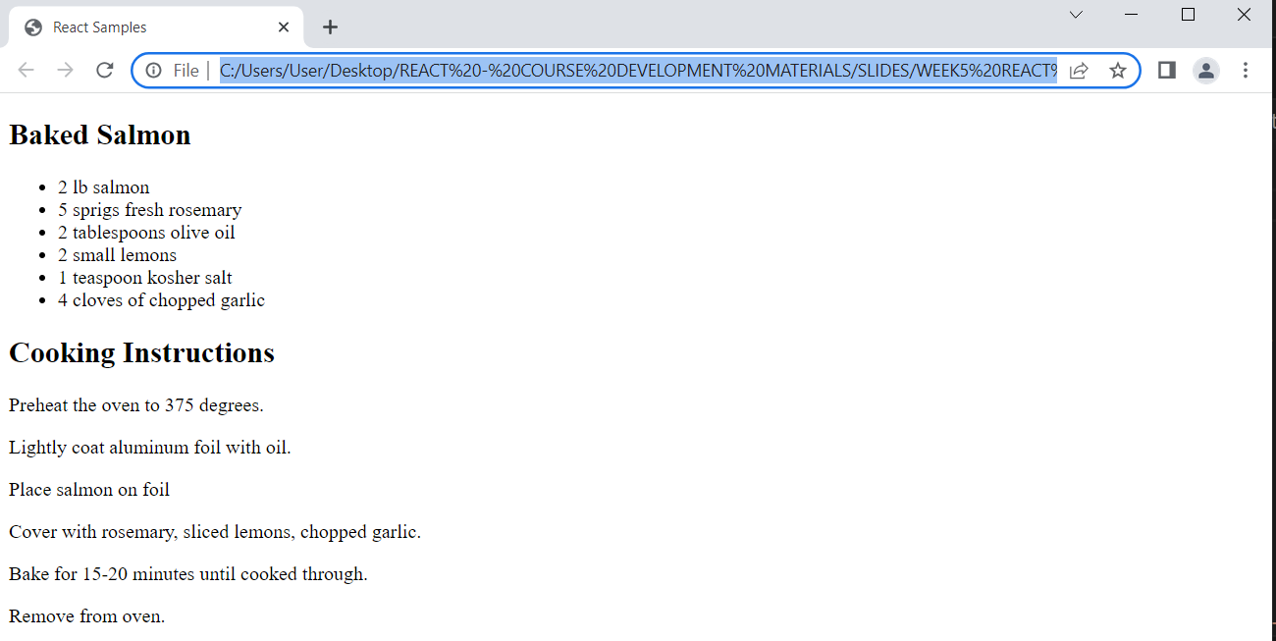

**SLIDE 11 – 14**

<!DOCTYPE html>

<html>

<head>

<meta charset="utf-8" />

<title>React Samples</title>

</head>

<body>

<!-- Target container -->

<div id="root">

    <section id="baked-salmon">

<h1>Baked Salmon</h1>

<ul class="ingredients">

<li>2 lb salmon</li>

<li>5 sprigs fresh rosemary</li>

<li>2 tablespoons olive oil</li>

<li>2 small lemons</li>

<li>1 teaspoon kosher salt</li>

<li>4 cloves of chopped garlic</li>

</ul>

<section class="instructions">

<h2>Cooking Instructions</h2>

<p>Preheat the oven to 375 degrees.</p>

<p>Lightly coat aluminum foil with oil.</p>

<p>Place salmon on foil</p>

<p>Cover with rosemary, sliced lemons, chopped garlic.</p>

<p>Bake for 15-20 minutes until cooked through.</p>

<p>Remove from oven.</p>

</section>

</section>

</div>

<!-- React library & ReactDOM (Development Version)-->

<script

src="https://unpkg.com/react@16.8.6/umd/react.development.js"></script>

<script src="https://unpkg.com/react-dom@16.8.6/umd/react-

dom.development.js"></script>

<script>

// Pure React and JavaScript code

var cre = React.createElement("h1",  {  id: "recipe-0" },  "Baked Salmon");

console.log(cre);

</script>

</body>

</html>

**SLIDE 16 - 18**

<!DOCTYPE html>

<html>

<head>

<meta charset="utf-8" />

<title>React Samples</title>

</head>

<body>

<!-- Target container -->

<div id="root"></div>

<!-- React library & ReactDOM (Development Version)-->

<script

src="https://unpkg.com/react@16.8.6/umd/react.development.js"></script>

<script src="https://unpkg.com/react-dom@16.8.6/umd/react-

dom.development.js"></script>

<script>

// Pure React and JavaScript code

const dish = React.createElement("h1",  null,  "Baked Salmon");

ReactDOM.render(dish,document.getElementById("root"));

</script>

</body>

</html>

**OUTPUT**

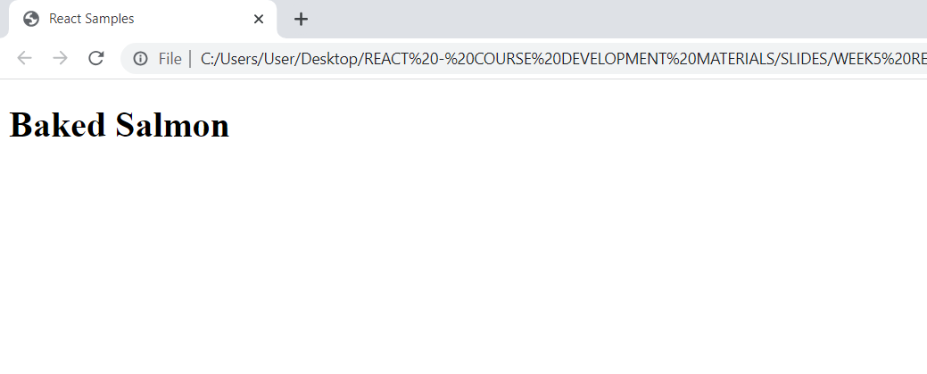

**SLIDE 19**

<!DOCTYPE html>

<html>

<head>

<meta charset="utf-8" />

<title>React Samples</title>

</head>

<body>

<!-- Target container -->

<div id="root"></div>

<!-- React library & ReactDOM (Development Version)-->

<script

src="https://unpkg.com/react@16.8.6/umd/react.development.js"></script>

<script src="https://unpkg.com/react-dom@16.8.6/umd/react-

dom.development.js"></script>

<script>

// Pure React and JavaScript code

const dish = React.createElement("h1",  null,  "Baked Salmon");

const dessert = React.createElement("h2",  null,  "Coconut Cream Pie");

ReactDOM.render([dish,  dessert], document.getElementById("root"));

</script>

</body>

</html>

**OUTPUT**

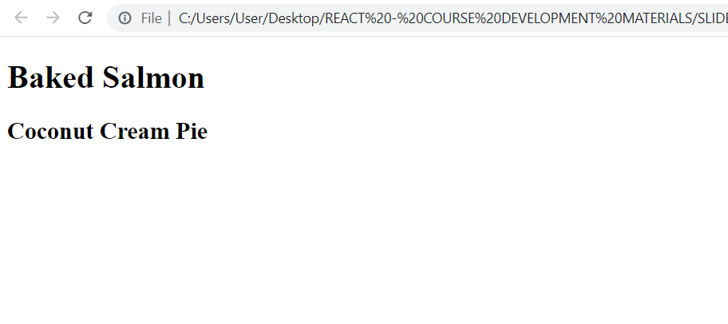

**SLIDE 21 – 26**

<!DOCTYPE html>

<html>

<head>

<meta charset="utf-8" />

<title>React Samples</title>

</head>

<body>

<!-- Target container -->

<div id="root"></div>

<!-- React library & ReactDOM (Development Version)-->

<script

src="https://unpkg.com/react@16.8.6/umd/react.development.js"></script>

<script src="https://unpkg.com/react-dom@16.8.6/umd/react-

dom.development.js"></script>

<script>

// Pure React and JavaScript code

const list = React.createElement(

"ul",

null,

React.createElement("li",  null,  "2 lb salmon"),

React.createElement("li",  null,  "5 sprigs fresh rosemary"),

React.createElement("li",  null,  "2 tablespoons olive oil"),

React.createElement("li",  null,  "2 small lemons"),

React.createElement("li",  null,  "1 teaspoon kosher salt"),

React.createElement("li",  null,  "4 cloves of chopped garlic")

);

console.log(list);

</script>

</body>

</html>

**OUTPUT**

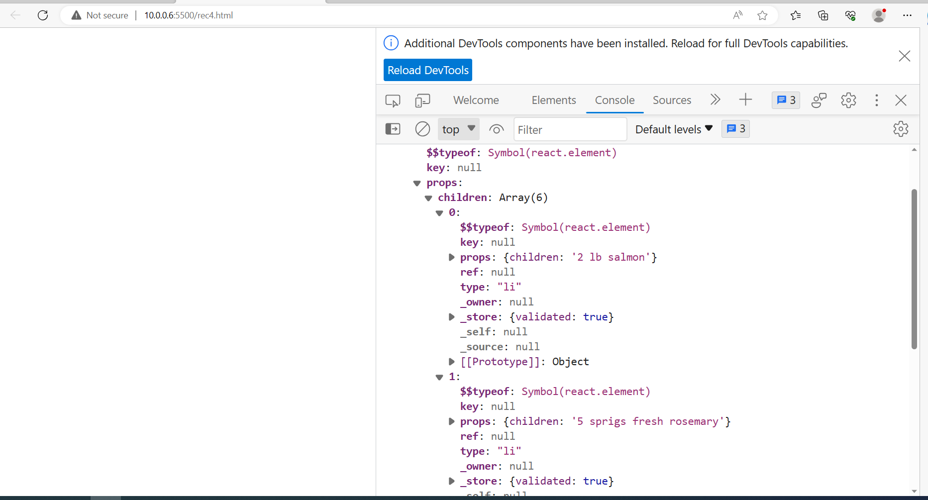

**SLIDE 27 – 28**

**To create the above script using React, we’ll use a series of createElement calls:**

<!DOCTYPE html>

<html>

<head>

<meta charset="utf-8" />

<title>React Samples</title>

</head>

<body>

<!-- Target container -->

<div id="root"></div>

<!-- React library & ReactDOM (Development Version)-->

<script

src="https://unpkg.com/react@16.8.6/umd/react.development.js"></script>

<script src="https://unpkg.com/react-dom@16.8.6/umd/react-

dom.development.js"></script>

<script>

// Pure React and JavaScript code

React.createElement(

"section",

{  id: "baked-salmon" },

React.createElement("h1",  null,  "Baked Salmon"),

React.createElement(

"ul",

{  className: "ingredients" },

React.createElement("li",  null,  "2 lb salmon"),

React.createElement("li",  null,  "5 sprigs fresh rosemary"),

React.createElement("li",  null,  "2 tablespoons olive oil"),

React.createElement("li",  null,  "2 small lemons"),

React.createElement("li",  null,  "1 teaspoon kosher salt"),

React.createElement("li",  null,  "4 cloves of chopped garlic")

),

React.createElement(

"section",

{  className: "instructions" },

React.createElement("h2",  null,  "Cooking Instructions"),

React.createElement("p",  null,  "Preheat the oven to 375 degrees."),

React.createElement("p",  null,  "Lightly coat aluminum foil with oil."),

React.createElement("p",  null,  "Place salmon on foil."),

React.createElement("p",null,"Cover with rosemary, sliced lemons, chopped garlic."),

React.createElement("p",null,"Bake for 15-20 minutes until cooked through."),

React.createElement("p", null, "Remove from oven.")

)

);

</script>

</body>

</html>

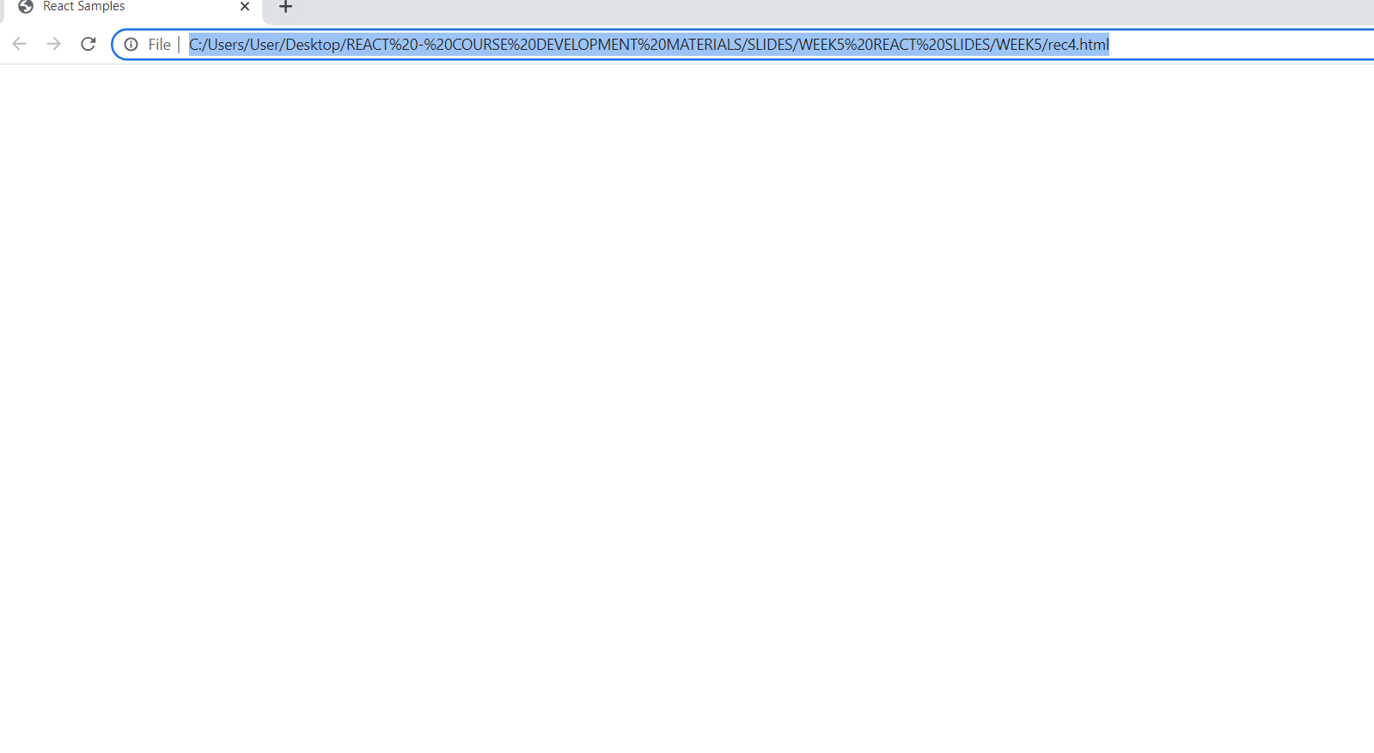

**SLIDE 29 – 34**

<!DOCTYPE html>

<html>

<head>

<meta charset="utf-8" />

<title>React Samples</title>

</head>

<body>

<!-- Target container -->

<div id="root"></div>

<!-- React library & ReactDOM (Development Version)-->

<script

src="https://unpkg.com/react@16.8.6/umd/react.development.js"></script>

<script src="https://unpkg.com/react-dom@16.8.6/umd/react-

dom.development.js"></script>

<script>

// Pure React and JavaScript code

React.createElement(

"ul",

null,

React.createElement("li",  null,  "2 lb salmon"),

React.createElement("li",  null,  "5 sprigs fresh rosemary"),

React.createElement("li",  null,  "2 tablespoons olive oil"),

React.createElement("li",  null,  "2 small lemons"),

React.createElement("li",  null,  "1 teaspoon kosher salt"),

React.createElement("li",  null,  "4 cloves of chopped garlic")

);

const items = [

"2 lb salmon",

"5 sprigs fresh rosemary",

"2 tablespoons olive oil",

"2 small lemons",

"1 teaspoon kosher salt",

"4 cloves of chopped garlic"

];

React.createElement("ul",

{  className: "ingredients" },

items.map(ingredient => React.createElement("li", null, ingredient))

);

</script>

</body>

</html>

**OUTPUT**

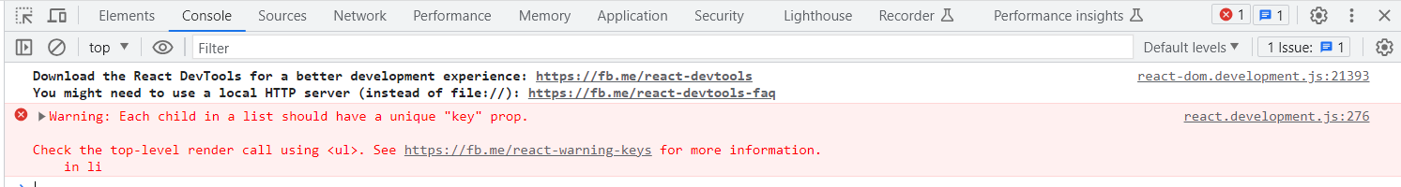

**SLIDE 35 – 38**

**adding this to each list item will clear the console warning.**

<!DOCTYPE html>

<html>

<head>

  <meta charset="utf-8" />

  <title>React Samples</title>

</head>

<body>

  <!-- Target container -->

  <div id="root"></div>

  <!-- React library & ReactDOM (Development Version) -->

  <script src="https://unpkg.com/react@16.8.6/umd/react.development.js"></script>

  <script src="https://unpkg.com/react-dom@16.8.6/umd/react-dom.development.js"></script>

  <script>

    const items = [

      "2 lb salmon",

      "5 sprigs fresh rosemary",

      "2 tablespoons olive oil",

      "2 small lemons",

      "1 teaspoon kosher salt",

      "4 cloves of chopped garlic"

    ];

    const list = React.createElement(

      "ul",

      { className: "ingredients" },

      items.map((ingredient, i) =>

        React.createElement("li", { key: i }, ingredient)

      )

    );

    ReactDOM.render(list, document.getElementById("root"));

  </script>

</body>

</html>

**OUTPUT**

